This shows a typical screen which an applicant would see. Note the menu bar at the top of the screenshot: the downward facing arrows indicate that there are several options to select from. This screen was selected from the Applications menu.

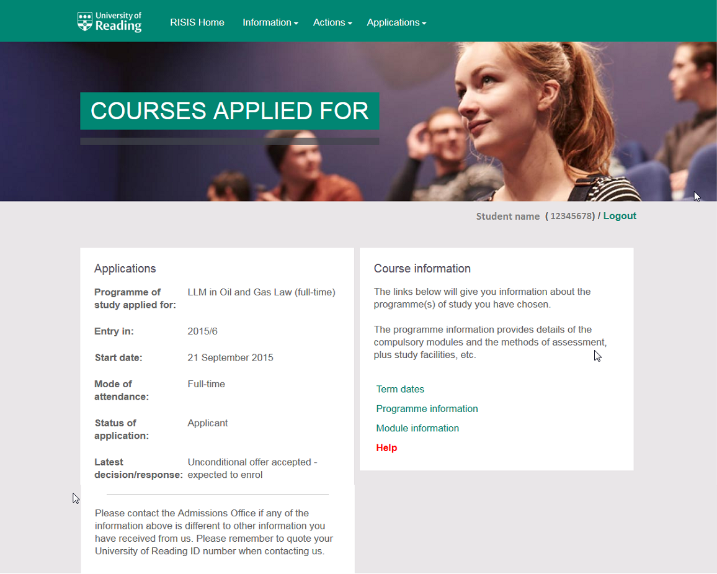

This shows a typical screen that a student might see. The page was selected from the Information menu.
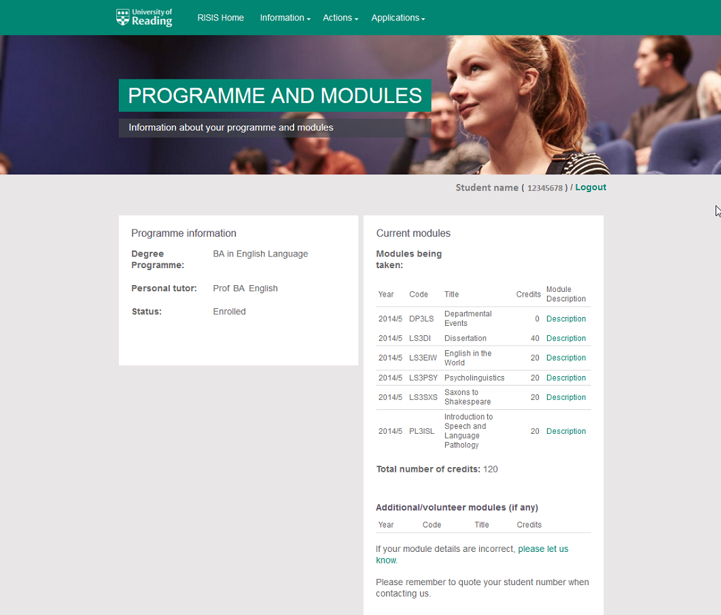

The staff pages have the menu down the left hand side and don’t have the photo bar across the top. This is a typical screen for a tutor’s view.
