**MAINTENANCE SERVICES**

**HEALTH & SAFETY:**

**ORGANISATION & MANAGEMENT ARRANGEMENTS**

**1.0 Statement of Intent**

Maintenance Services is committed to ensuring that the Health, Safety and Welfare of its employees and others is not adversely affected by our working environment or the work we do. Werecognise that whilst it is not possible to remove all risks from the working environment it is our responsibility to ensure that risks are identified and, where practicable, properly managed.

**2.0 Summary of Organisational H&S Arrangements**

**3.0 Key Responsibilities**

**3.1 Vice Chancellor**

The Vice Chancellor has overall responsibility for the health, safety and welfare of all persons employed by University. Ensuring that students, staff and others, who may be affected by the University’s activities and services are protected, so far as is reasonably practicable, from risk(s) to their health, safety and welfare.

**3.2 Pro-Vice Chancellor (Resource)**

The Pro-Vice Chancellor (resource) has specific responsibility for the allocation of resource, including financial and physical resources for the management of health, safety & welfare.

**3.3 Director of Estates**

The Director of Estates has overall responsibility for the health, safety and welfare of all persons employed by Estates and ensuring that students, staff and others, who may be affected by Estates’ activities and services are protected, so far as is reasonably practicable, from risk(s) to their health and safety. Key responsibilities include:

* Providing health and safety leadership for the function
* Reporting to the University’s Health & Safety Committee on matters affecting health and safety.
* Ensuring that sufficient resource is in place to enable Estates to achieve its statutory, health, safety and welfare obligations
* Ensuring that appropriate Health & Safety policy, procedure and organisational arrangements are in place across Estates, together with objectives for continual H&S improvement
* Ensuring that sufficient resource is in place for professional/competent advice and assistance.

**3.4 Director of Facilities Maintenance**

The Director is responsible for the effective management of health and safety within their area. Key responsibilities include:

* Providing health and safety leadership for the department
* Ensuring that appropriate Health & Safety policy, procedure and organisational arrangements are in place across the department and these are periodically reviewed and updated
* Allocating adequate resources so that safety and health risks can be managed effectively (prioritising actions where necessary)
* Establishing key health and safety objectives for the department, on an annual basis;
* Ensuring that accidents, incidents, occupational diseases, hazards and near misses are reported in accordance with University procedures so that trends can be identified in a timely manner
* Monitoring occupational safety and health performance within the department.
* Ensuring that adequate arrangements are in place to monitor health and safety procedural compliance by both in-house staff and external contractors and consultants
* Ensuring that effective arrangements are in place to monitor the competency of employees, in order to safely carry out their designated roles
* Ensuring that risk assessments are utilised to prioritise programmes of maintenance and other works
* Supporting the University Health, Safety and Welfare Committee and the Health & Safety Services department with safety investigations, audits etc.
* Ensuring that Health & Safety issues are considered at all management and team meetings
* Ensuring effective consultation on health and safety matters and the dissemination of relevant information
* Liaising with other stakeholders to share good health and safety practice

**3.5 Heads of Department**

The Head of Department is responsible for the effective management of health and safety within their operational department. Key responsibilities include:

* Ensuring that employees within their control understand and accept their personal responsibilities and are competent to carry out their designated roles, having access to relevant information, instruction and training;
* Ensuring that employees within their control are provided with and use the necessary PPE, tools and equipment to undertake their roles safely
* Ensuring that plant and equipment is regularly serviced and maintained
* Ensuring that general and task specific/dynamic risk assessments are undertaken and that operational staff understand the risk assessment and implement necessary risk controls
* Ensuring arrangements for employee welfare and procedures for dealing with emergency situations are in place and fit for purpose
* Ensuring that effective arrangements are in place within the department to periodically review/audit workplaces, working practices, tools, plant, equipment etc.
* Monitoring accident & incident records, occupational health reports and other data to identify trends and highlight areas where additional resources may be required

**3.6 Maintenance Managers**

Managers and others with staff supervisory duties are responsible for health and safety within their teams/area of responsibility. Key responsibilities include:

* Ensuring that their team members recognise and understand their personal responsibilities with regard to health and safety
* Ensuring their teams have access to relevant and necessary information, instruction and training
* Ensuring that employees within their teams have access to the department’s Health and Safety policy and procedure, and that these are implemented and complied with
* Ensuring general and specific risk assessments are available, that dynamic risk assessments are undertaken where appropriate and that risk controls and recommendations are acted upon
* Ensuring provision & utilisation of equipment, facilities, etc. identified through risk assessment, safe systems of work etc., including personal protective equipment
* Encouraging the involvement of employees and other interested parties in the day to day management of occupational safety and health
* Ensuring all accidents, incidents, occupational diseases, hazards and near misses are reported in accordance with procedures
* Ensuring that Health & Safety issues are considered at all team meetings
* Ensuring that effective arrangements are in place within their specific area of responsibility to periodically review/audit workplaces, working practices, tools, plant, equipment etc.
* Ensuring effective consultation on health and safety matters and the dissemination of relevant information
* Liaising with other stakeholders to share good health and safety practice

**3.7 Maintenance Direct Labour Team & Other Staff**

All employees (including those on a temporary or fixed term contracts), have a responsibility for their own and others health and safety, not to misuse anything provided for the purposes of health and safety, and to co-operate with the department to enable it to discharge its health and safety obligations. Key responsibilities include:

* Complying with the requirements of the health and safety policy, arrangements, procedures and other relevant health and safety documentation
* Participating in any instruction or training which has been provided for the purposes of health and safety
* Assisting in the completion of risk assessments, where required, and implementing/complying with risk assessment control measures where identified
* Using equipment, facilities, etc., as per training/information provided and utilising any PPE, safety equipment, facilities etc., as required by training/instructions received
* Reporting known hazards in the workplace which may have not been previously identified or assessed, including any defects to equipment which is used or which has been personally issued
* Being aware of the emergency arrangements for your workplace and participating in any drills or exercises
* Not entering into any contracts for the purchase of goods and / or services unless specifically authorised
* Not bringing any items from home for use at work, unless it has been issued / authorised by work
* Reporting accidents, incidents, occupational diseases, hazards and near misses in accordance with procedures
* Attending and discussing health and safety at team and other meetings; such as to give feedback on new or changed working practices, to highlight any areas of concern or make suggestions to enable improvements in workplace practices or conditions.

**3.8 Maintenance Project Team & Contract Managers**

In addition to their responsibilities as a Maintenance Manager, Project & Contract Managers, along with others who supervise contractors, are responsible for health and safety of the contractors and consultants working on maintenance work that they oversee. Key responsibilities include:

* Ensuring that contractors and consultants prepare the necessary risk assessments, method statements, permits to work etc. and these are provided for review and approval by the University’s Project Manager/Contract Manager/Supervisor before work commences
* Ensuring that contractors and consultants utilise appropriate safety equipment, PPE, identified through risk assessment, safe systems of work, etc.
* Ensuring that contractors’ and consultants’ staff are suitably trained and competent to undertake the work allocated to them
* Ensuring all accidents, incidents, occupational diseases, hazards and near misses are reported in accordance with procedures
* Ensuring that contractors and consultants comply with the University’s health & safety policy, procedures and guidance.
* Ensuring contractor’s health and safety competency will be assessed through their membership of the Contractors Health and Safety (CHAS) Assessment Scheme

**3.9 Duty Holders**

Duty Holders have been appointed in a number of specialist areas, where maintenance works are considered to be safety critical. Duty Holders have been appointed in the following areas:

* High Voltage Electricity
* Low Voltage Electricity
* Lifts and Lifting Equipment
* Gas Safety
* Legionella & Water Quality

The Duty Holders have responsibility for the oversight/monitoring of relevant legislation in their area of responsibility, ensuring that the department’s maintenance policy, procedures and guidance meet the University’s statutory obligations, that the necessary record documents for examination, inspection etc. are maintained and that Standard Operating Procedures (SOP) are developed.

The Duty Holders also have a responsibility to report to the relevant Estates Directors any concerns about safety and/or statutory compliance.

**4.0 Advice & Support**

In addition to the advice and support provided by the management team, Maintenance staff have access to help and support from the following sources:

**4.1 Health & Safety Services**

Operates independently of Estates, providing impartial advice and assistance on:

* General health & safety law
* The development of policy, procedure, risk assessment, safe working practices, statutory compliance etc.
* The implementation of appropriate risk controls based upon risk assessment
* Training of in-house staff and retained contractors and consultants
* Monitoring of the work place and high hazard activities
* Accident reporting and trend analysis
* Health & Safety inspection and audit, including review of management systems and subject specific reviews of high hazard activities

Specialist advice can also be provided on general construction safety, laboratory safety, asbestos management and fire safety.

**4.2 University Safety Office and Occupational Health Service**

The Occupational Health Service provides advice and assistance in relation to:

* Pre-employment health screening;
* Health surveillance/screening
* Advice on reasonable adjustments to working practices
* Return to work assessment and advice
* Health promotion

**4.3 External Specialist Advice and Support**

Maintenance Services utilise a range of specialist consultants for general and specialist safety advice. This has included general H&S management system audit, risk assessment review, laboratory advice, compliance with legislation etc. Staff should consult their line manager where additional specialist support is thought to be required.

**5.0 Acknowledgement of Contents**

**5.1** The document will be periodically reviewed and re-issued to existing staff and will be provided to new staff as part of their induction.

All employees are required to acknowledge they have received, read and understood the content of this document. This will be provided for by way of a ‘receipt form’ which must be signed and returned to through your line manager.



***S. J. Boon***

***Maintenance Services, Director***

*Issue Date: 1 August 2019*

*Next Review: 1 August 2022*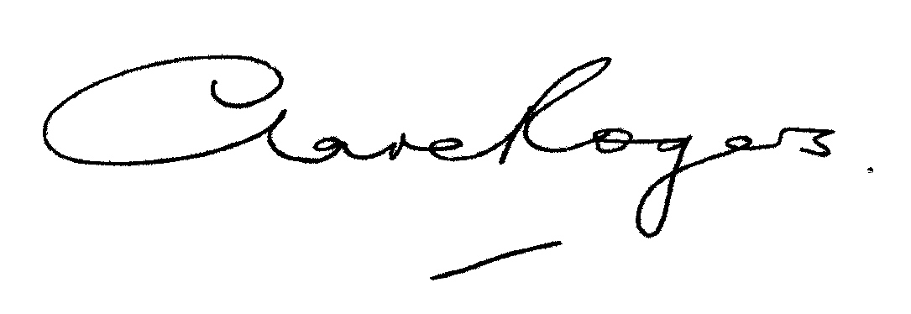

*Version: 3.0*